**Chapter 1: Introduction**

* 1. **General**

Welcome to “DIGICOIN” , your gateway to the dynamic world of cryptocurrencies. Our platform seamlessly integrates the latest advancements, combining Alan AI for intelligent features and Firebase for a robust backend. With secure login functionalities, personalised watch lists, and a user-friendly interface,it ensures you're always in control of your crypto portfolio. Experience the convenience of voice-navigated screens, allowing you to effortlessly explore the vast landscape of digital assets. Stay informed and make informed decisions with interactive charts that visualise the latest trends in the cryptocurrency market. Join us on this journey where innovation meets user-centric design, and be your trusted companion in navigating the exciting realm of crypto investments.

**1.2 Problem Statement**

When it comes to dealing with cryptocurrencies, many people find it hard to use websites that are easy to understand and have all the useful features. The existing crypto sites often lack a simple layout, and tools to help users understand how the market is doing. People also have trouble keeping track of their crypto investments on different devices, and using voice commands on these websites can be tricky. To make things better, we need a crypto website that not only solves these issues but also includes a cool graph feature. This graph will show how different cryptocurrencies are changing in value over time, making it easier for users to make smart decisions. With a website that is easy to use, safe, and has this graph feature, people can have a better experience exploring, managing, and keeping up with the exciting world of digital money.

**PROBLEMS IN THE CURRENT SCENARIO:**

1.**User Interface Issues:** Current cryptocurrency platforms lack user-friendly interfaces. Difficulty for users, especially beginners, in navigating and understanding the platforms.

2.**Security Concerns:**Existing platforms face security vulnerabilities, raising concerns about the safety of user data and transactions.

3.**Limited Real-time Visualisation:** Absence of tools for real-time visualisation of cryptocurrency trends.

4. **Voice-Activated Controls Absent:** Current platforms lack voice-activated controls, limiting accessibility and ease of use.

5. **Need for Accessibility and Security:** There is a critical need for a more accessible and secure cryptocurrency platform.

*6.* **Integration of Dynamic Graphs:**  Users lack access to dynamic graphs for visualising real-time trends in the cryptocurrency market. Integration of dynamic graphs is crucial for providing users with valuable insights.

7.**Empowering Informed Decision-Making:** The aim is to create a platform that empowers users to make informed decisions in the dynamic cryptocurrency market.

Access to real-time data and dynamic graphs is essential for enhancing decision-making capabilities.

* 1. **Expected Outcome**

The expected result of ‘**DIGICOIN**’ aims to be the preferred platform for cryptocurrency enthusiasts, seamlessly integrating data, news, interactive graphs, AI-driven features, and a customizable watchlist option to deliver a holistic and insightful user-centric experience.

**Chapter 2: Project Objective**

THE BASIC OBJECTIVES OF THE PROPOSED SYSTEM:

1. Make a super cool cryptocurrency platform.

2. Add smart features with Alan AI.

3. Use Firebase for a strong backend.

4. Let people make their own watchlist.

5. Make it all about what users want.

6. Keep things safe and easy to use.

7. Create a really advanced platform.

8. Always come up with new stuff for crypto fans.

**Chapter 3: Project Description**

**3.1 Features**

The platform employs Alan AI for voice commands, utilises Firebase for secure login and synced watchlists, prioritises a user-friendly design, displays real-time visual updates on cryptocurrency values, offers educational resources, and emphasises robust security and an intuitive interface for a seamless user experience.

1. Easy Talking: Alan AI for seamless voice commands.

2. Safe Login and List: Firebase for secure login and synced watchlists.

3. Simple Look: User-friendly design for easy exploration.

4. See Changes Live: Visual updates on real-time cryptocurrency values.

5. Learn with Us: Educational resources for cryptocurrency understanding.

6. Secure Login and Watchlist: Firebase integration for robust security.

7. User-Friendly Interface: Intuitive design for a smooth experience.

8. Real-Time Market Analysis: Dynamic graphs for instant insights.

**3.2 Software Requirement**

HTML

CSS

REACT.JS

FIREBASE

CHART.JS

ALAN AI

**Chapter 4: Design Specification**

**4.1 Frontend**

The Frontend part is the core of any web application project. The frontend part of this project is made using HTML, CSS, Material UI, Bootstrap & JAVASCRIPT. The frontend part is written using functional components of React JS.

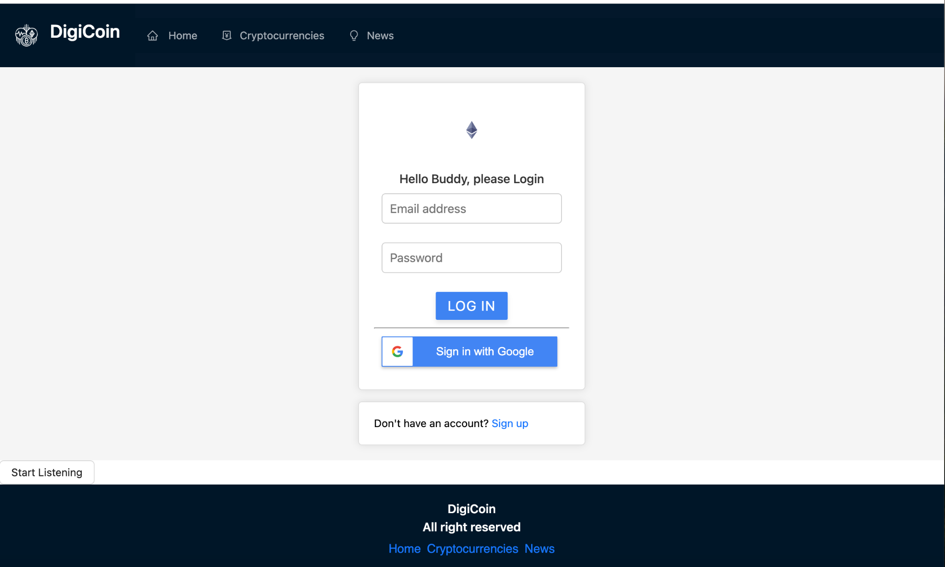***Figure 4.1.a-****Login Page*

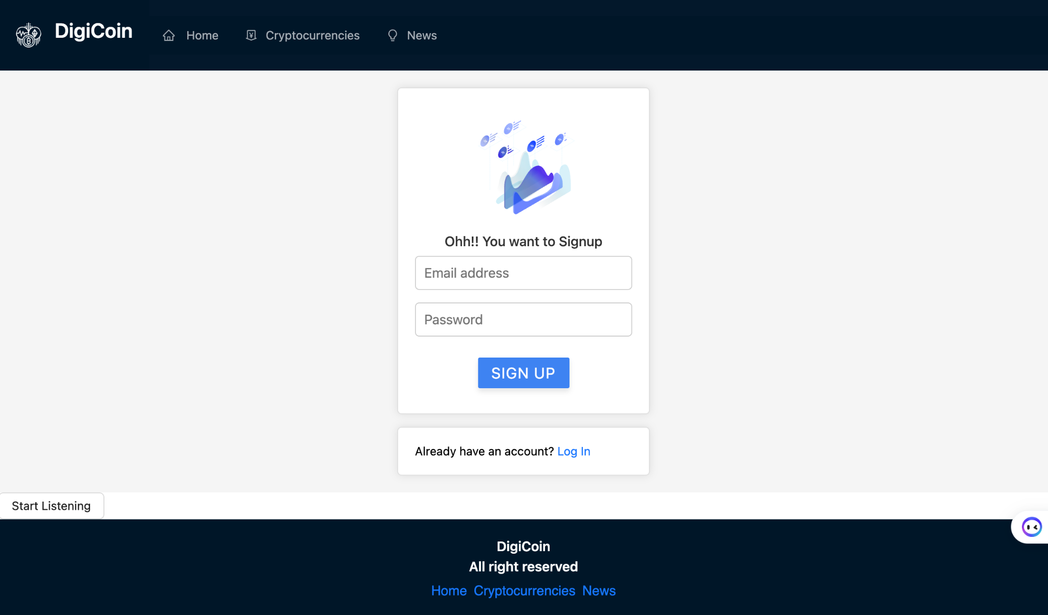

***Figure 4.1.b-****Signup Page*

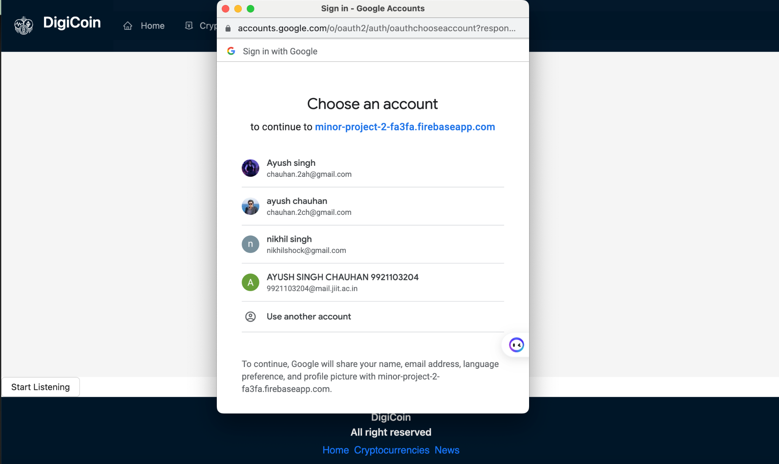

***Figure 4.1.c -*** *Google Login Page*

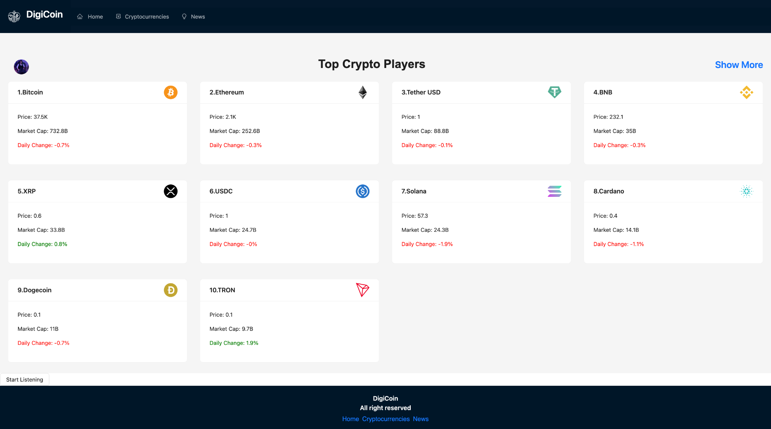

***Figure 4.1.d* -***HomePage*

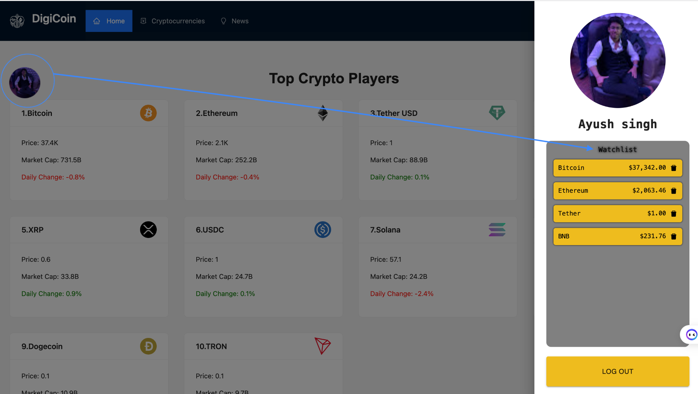

***Figure 4.1.e -****Watchlist*

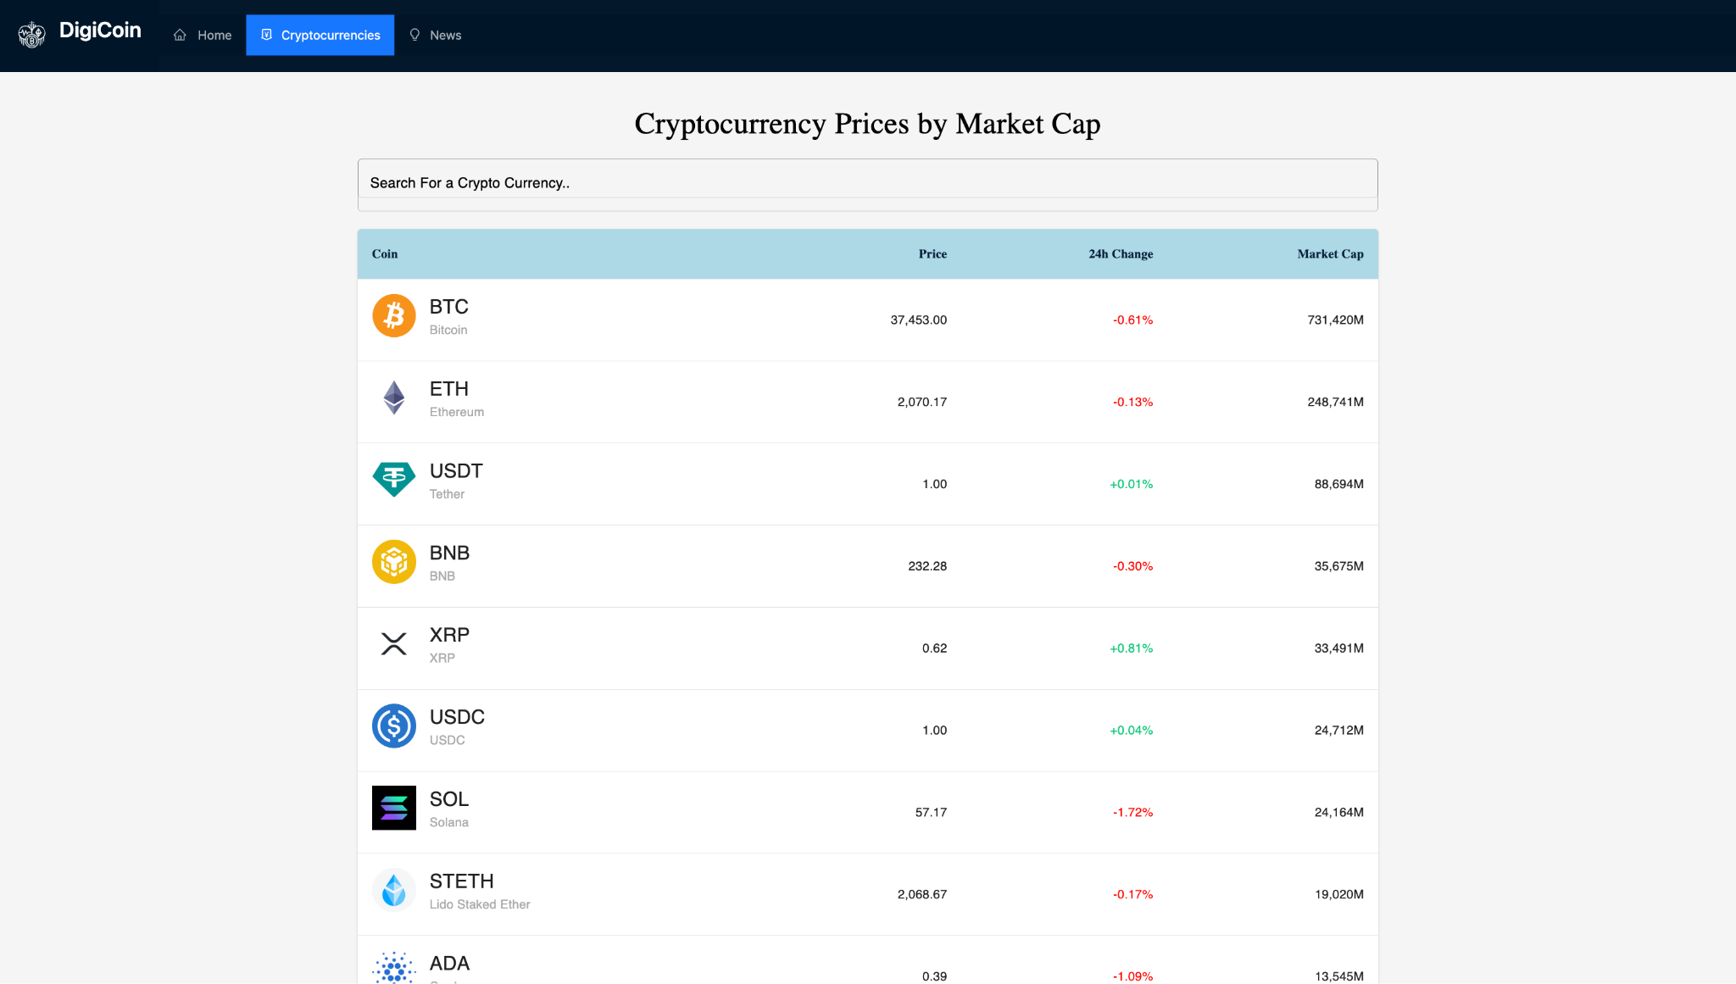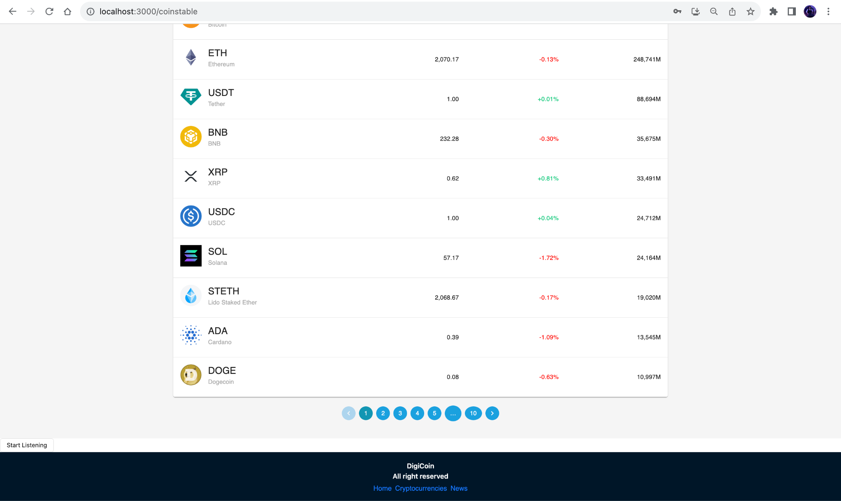***Figure 4.1.f-****CoinTable Page*

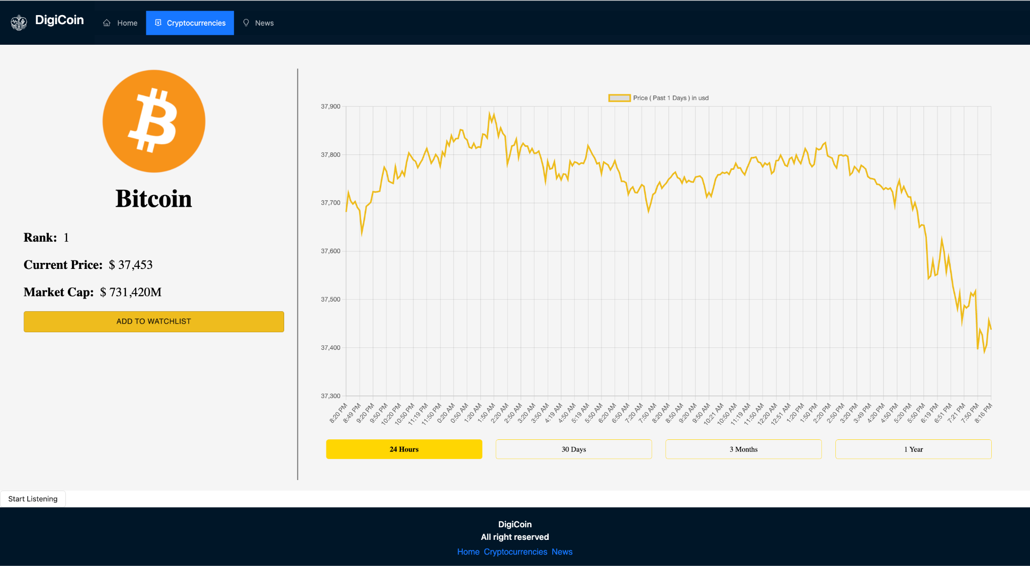

***Figure 4.1.g -****Charts Page(24 Hours)*

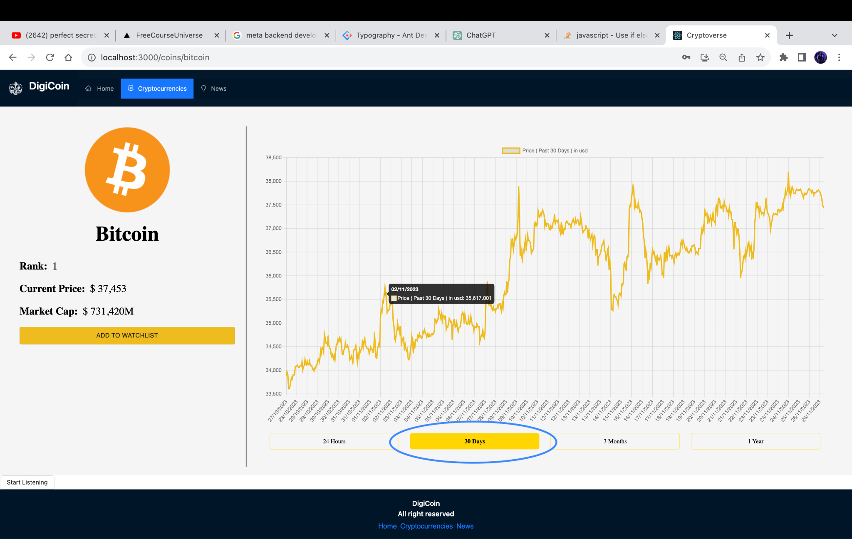

***Figure 4.1.h-****Charts Page(30 Days)*

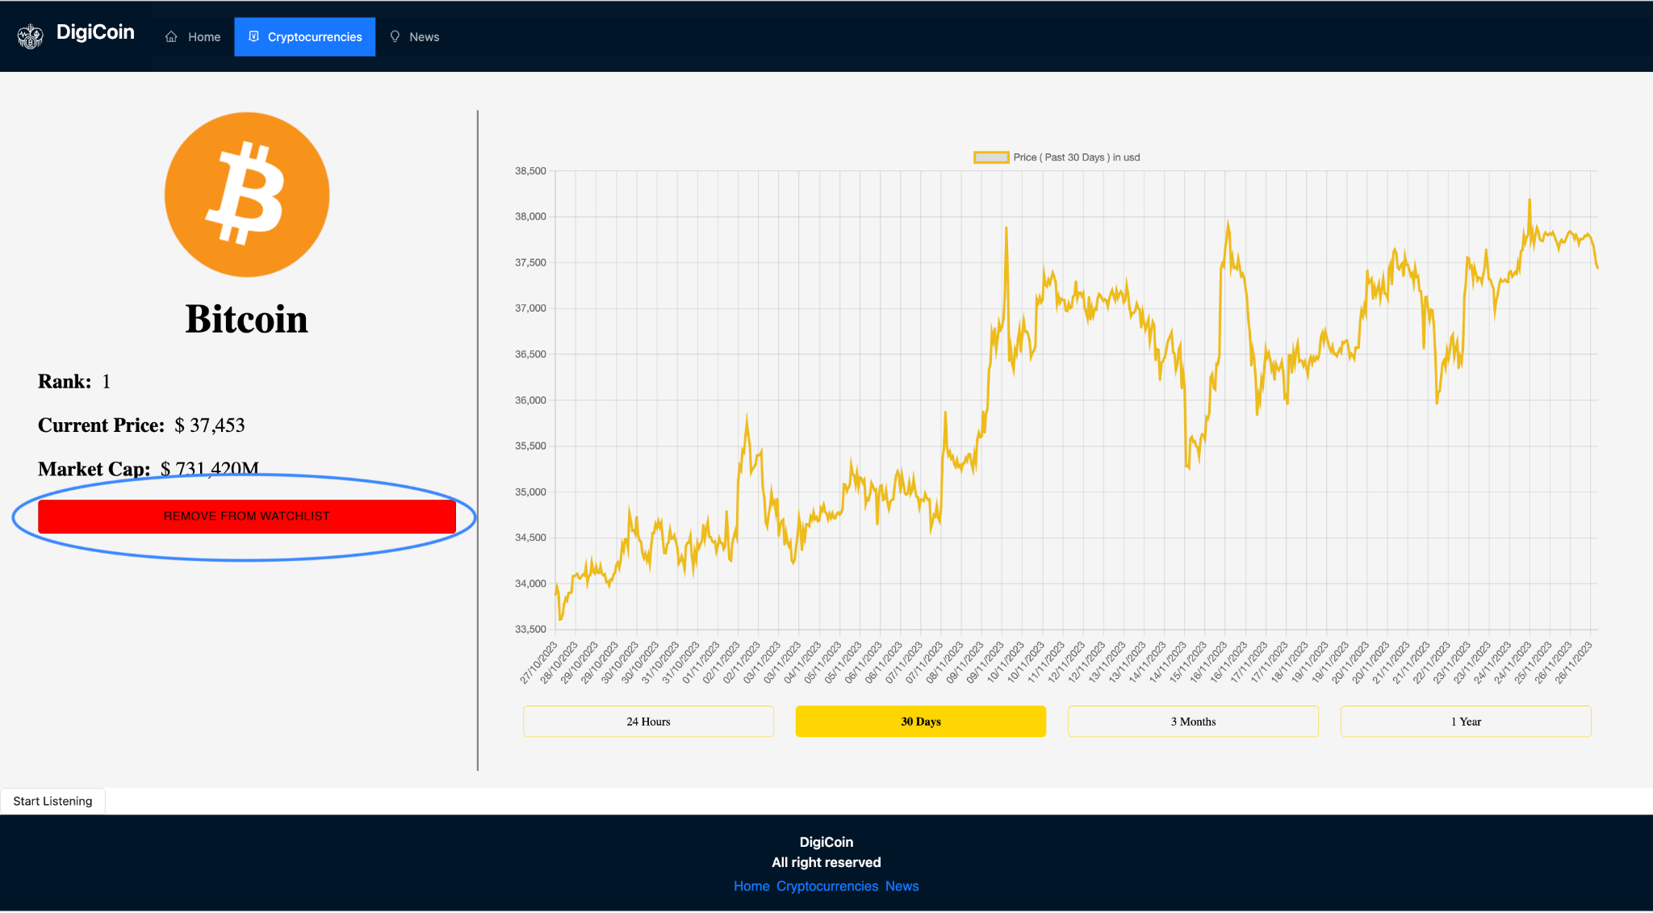

***Figure 4.1.i-****Added to watchlist*

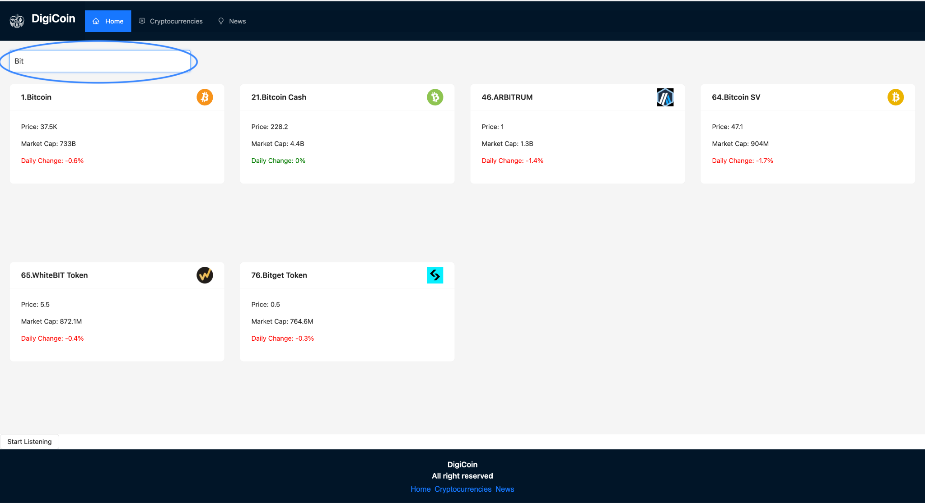

***Figure 4.1.j-****Search Cryptocurrency*

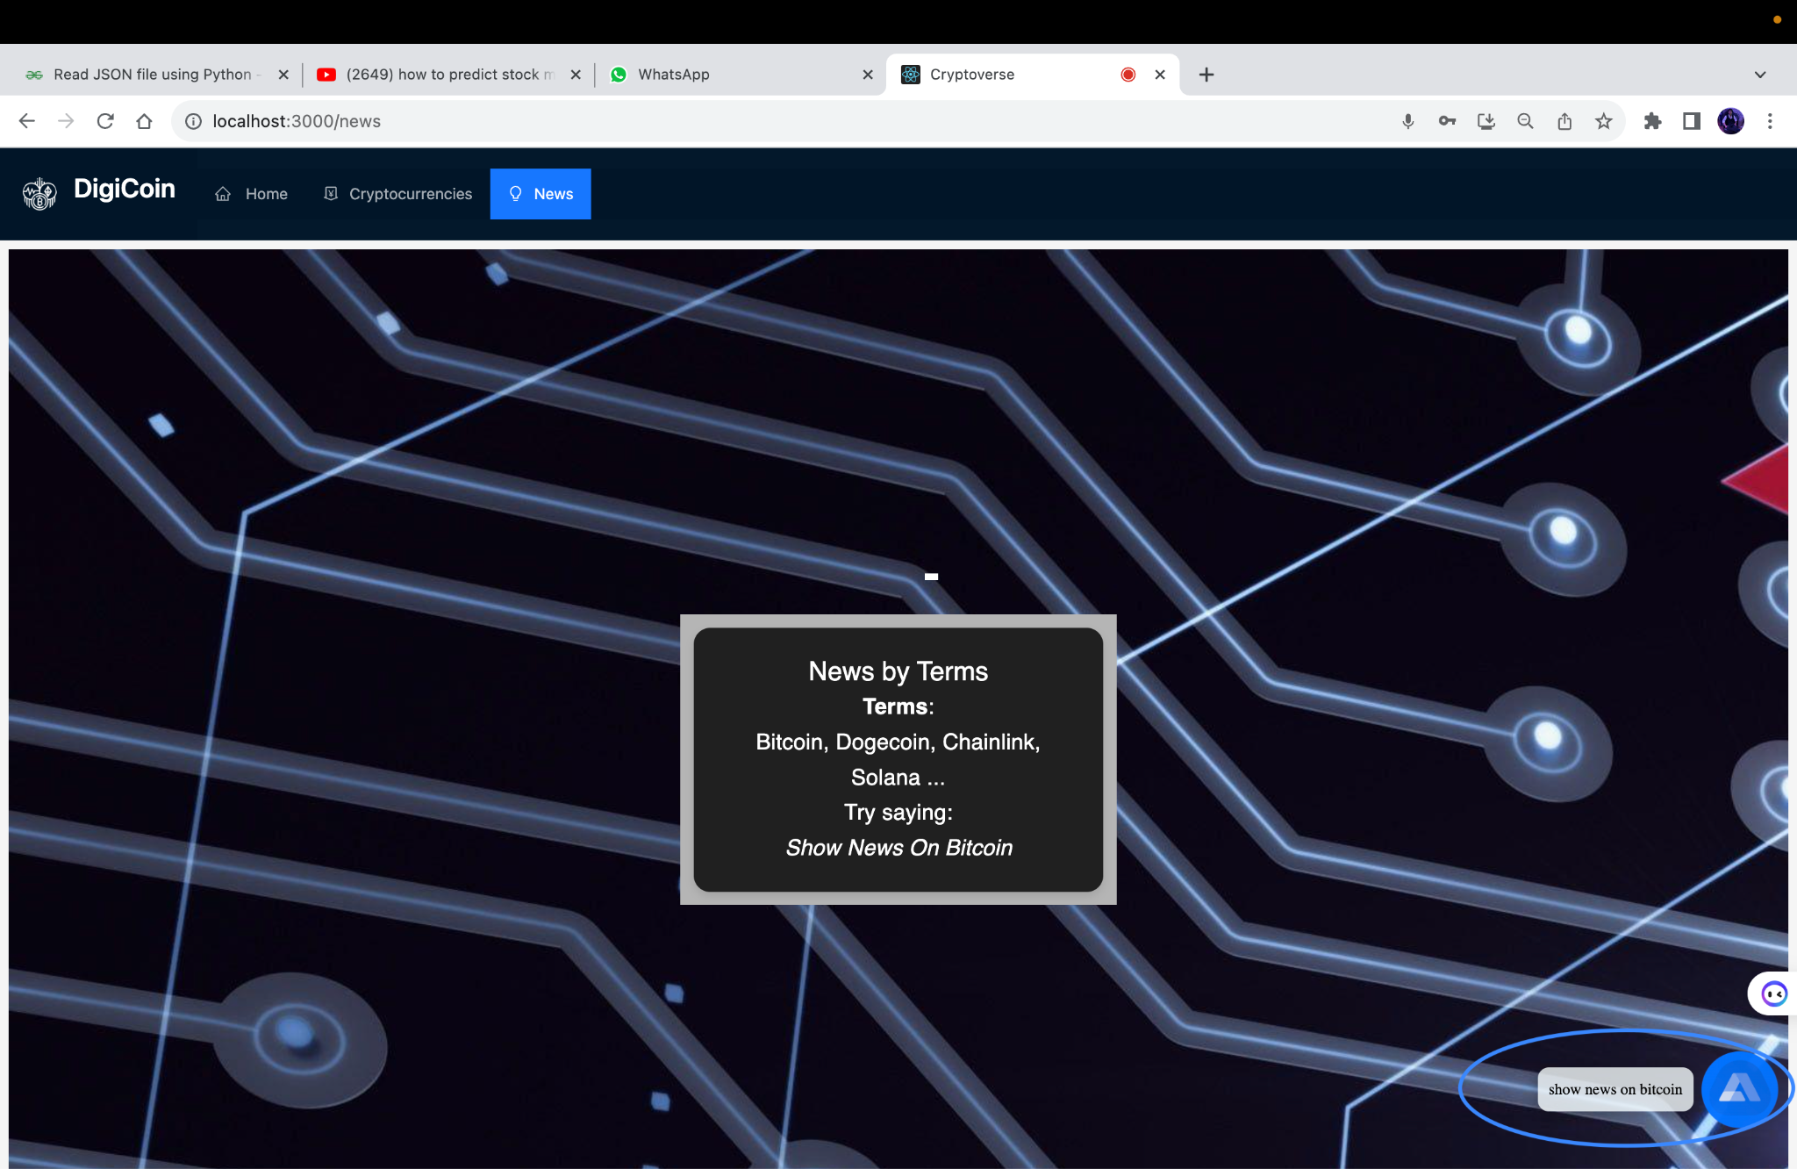

***Figure 4.1.k -****News Page (Alan AI API)*



***Figure 4.1.l -****News Page*

**4.2 Backend**

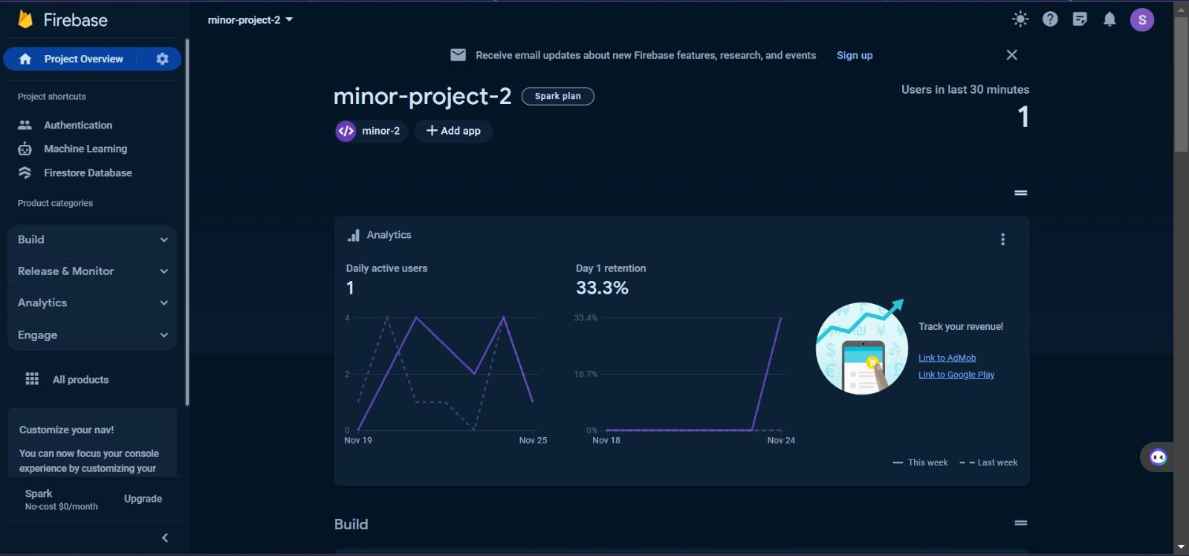

***Figure 4.2.a -****Firebase Homepage*

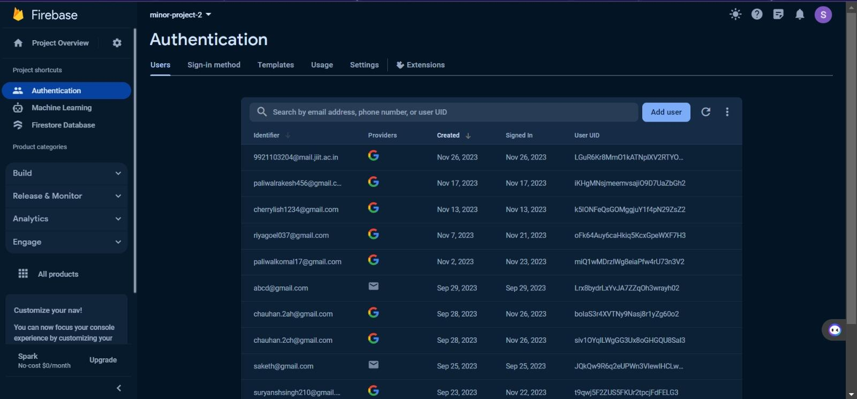

***Figure 4.2.b -*** *User Id’s (Firebase)*

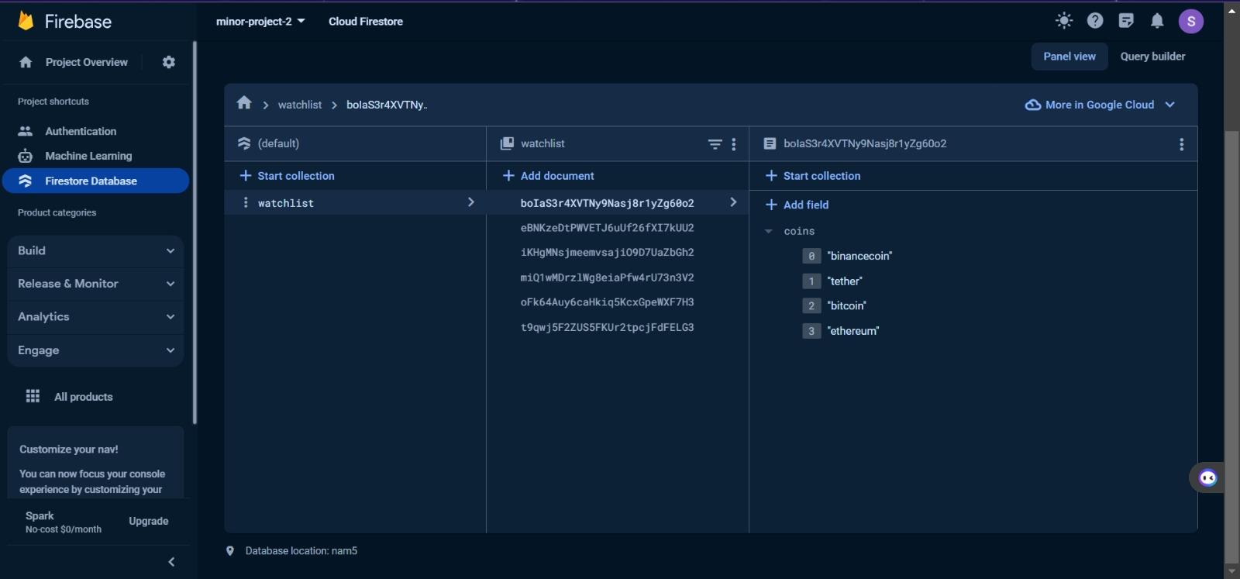

***Figure 4.2.c -****Watchlist Data(User id-1)*

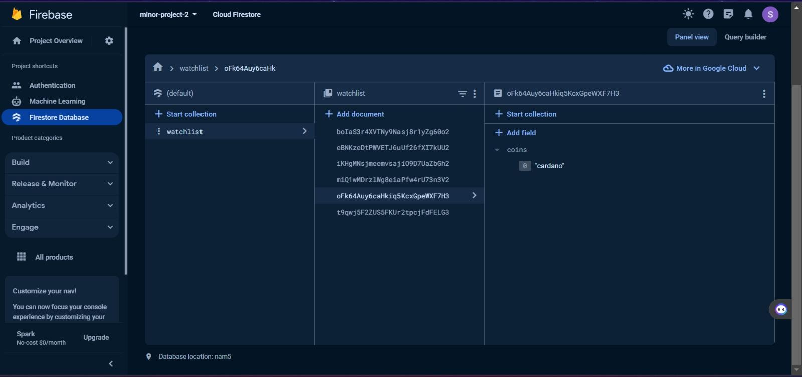

***Figure 4.2.d -****Watchlist Data (User id-2)*

**Chapter 5: Implementation**

**5.1 Frontend**

1. Homepage: Display top ten cryptocurrencies and load more using Rapid Crypto API.

2. Voice Navigation: Use Alan AI for hands-free navigation between pages.

3. Graph Page: Utilise Chart.js and Graph API for dynamic chart visualisations.

4. News Section: Integrate Alan AI to provide voice-commanded news updates.

5. Voice-Activated Routes: Enable users to change routes seamlessly using voice commands.

**5.2 Backend**

Backend Integration (Firebase): Implement Firebase for secure user authentication and backend functionality, ensuring a seamless login experience and enabling the creation and management of personalised watchlists.

**5.3 Database**

Leverage Firebase as the database system, ensuring secure user authentication and enabling the storage and management of personalised watchlists for a seamless and personalised user experience.

**5.4 Additional features**

1. Alan AI : Imagine talking to your crypto app like you talk to a friend! Alan AI makes it understand your voice commands, making things super easy.

2. Your Personal Crypto List: Think of a special list in your app that keeps all your favourite cryptocurrencies. It helps you remember and keep an eye on the ones you like.

3. Voice-Guided Journey: Your app is like a smart friend that listens to your voice and takes you to different pages. Just tell it where you want to go!

**Chapter 6: Skills Developed**

1. React Development: Mastered building dynamic and responsive interfaces using React.js

2. HTML & CSS Skills: Developed proficiency in structuring web pages and styling interfaces.

3. Firebase Integration: Acquired skills in integrating Firebase for secure authentication and backend functionality.

4. Voice-Activated Controls (Alan AI): Implemented Alan AI for voice-activated interactions, enhancing user experience.

5. Chart.js Visualization: Utilised Chart.js to create interactive and visually appealing charts.

6. API Integration: Integrated external APIs, like Rapid Crypto API, for real-time data retrieval.

7. UX Design Principles: Applied user experience design principles for an intuitive platform.

8. Project Management: Developed project coordination skills for feature integration.

9. Problem-Solving Aptitude: Enhanced problem-solving skills in addressing security and data visualisation challenges.

10. Continuous Learning: Cultivated a mindset for ongoing learning, staying updated on emerging technologies.

**Chapter 7: Results**

Create a user-friendly cryptocurrency platform allowing login, signup, and watchlist functionalities. Enable voice-activated news searches, utilizing Alan AI, to effortlessly access and display the latest information on desired cryptocurrencies in card format for a seamless user experience.

|  |  |  |  |
| --- | --- | --- | --- |
| **Feature** | **Input** | **Output** | **Expected Output** |
| Login | USERID , Password & Google Log In | User will login | If the username and password is correct it will log in else not |
| Search | Name of Cryptocurrency | All the Cryptocurrencies available which start or are related to that name. | All the Cryptocurrencies starting with the name. |
| Add User  (Sign Up) | Details of user name, email  , password etc. | New user added to the database | New user with its details added to the database |
| Add To Watchlist | - | Cryptocurrency with its Price is added to user’s Watchlist | New Cryptocurrency with its details added to the database |
| Watch Latest News | Search Using Voice command(Alan AI) | News of desired Cryptocurrency according to given command | Shows all latest news in the form of cards of that Cryporcurrency |

***Table 7.1-****Result*

**Chapter 8: Conclusion**

This crypto app is all about making things easy and personalized. With homepage featuring the latest cryptocurrencies, hands-free navigation using Alan AI, and dynamic charts for insights, it's a user-friendly experience. The backend, powered by Firebase, ensures secure logins and personalized watchlists. Plus, with Alan AI, The app becomes a smart friend, understanding voice commands for news updates and guiding you through your personalized crypto journey . It's like having a helpful friend who makes understanding cryptocurrencies easy and simple.

**Chapter 9: Future Work**

**9.1 Cryptocurrency price prediction model:**

In exploring future trends within the cryptocurrency domain, the utilization of advanced predictive models, such as the Random Forest Regressor, emerges as a pivotal avenue for forecasting market movements. The application of this model holds promise in deciphering evolving patterns and trends in Bitcoin and other cryptocurrencies. The Random Forest Regressor, known for its robustness in handling large datasets and capturing complex relationships between variables, offers an opportunity to enhance our understanding of future price dynamics. Leveraging historical price data, trading volumes, sentiment analysis, and technical indicators, this model enables us to forecast potential market trajectories with a degree of accuracy. By harnessing the Random Forest Regressor's capabilities, we aim to glean insights into the nuanced intricacies of cryptocurrency markets, thereby empowering investors and stakeholders with informed decision-making tools to navigate the ever-evolving landscape of digital assets.

**CERTIFICATE**

This is to certify that the work titled “**DIGICOIN**” submitted by Komal Paliwal (Enrollment no. 9921103035), Riya Goyal (Enrollment no. 9921103017), Suryansh Singh (Enrollment no. 9921103208), Ayush Singh (Enrollment no. 9921103204) of B.Tech of Jaypee Institute of Information Technology, Noida has been carried out under my supervision. This work has not been submitted partially or wholly to any other University or Institute for the award of any other degree or diploma.

Digital Signature of Supervisor :

Name of Supervisor : Ambalika Sarkar

Designation : Assistant Professor

Date : 02/12/2023

**References**

**Book**

[1] The Road to Learn React: Your Journey to Master Plain Yet Pragmatic React. Js

**Journal Article**

[2]F. Fang, C. Ventre, M. Basios, H. Kong, L. Kanthan, L. Li, D. Martinez-Regoband, F. Wu,

Cryptocurrency trading: A comprehensive survey (2020). arXiv:2003.11352.

**Online**

[3][www.w3schools.com](http://www.w3schools.com)

[4][www.coingecko.com](http://www.coingecko.com)

[5]www.bing.com

**Technical Report**

[6] G. Giudici, A. Milne, D. Vinogradov, Cryptocurrencies: market analysis and perspectives, Journal of Industrial and Business Economics 47 (2020) 1–18.